**Partitioning a 2 Gig USB drive to accept CentOS.**

To be able to partition a 2 Gig USB drive and not obtain the error “could not allocate requested partitions not enough disk space”, follow the instructions below. Windows 7 Professional is being used in this example. The instruction below will create a USB drive that is unformatted. Other operating systems have similar commands to perform these instructions.

Start Windows 7.

Install USB drive into a USB port.

Click on the windows start button in the lower left corner of the screen.

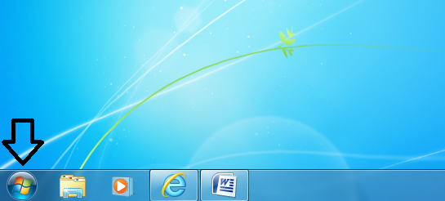

In the “search programs and files” box type “diskpart” without the quotes.

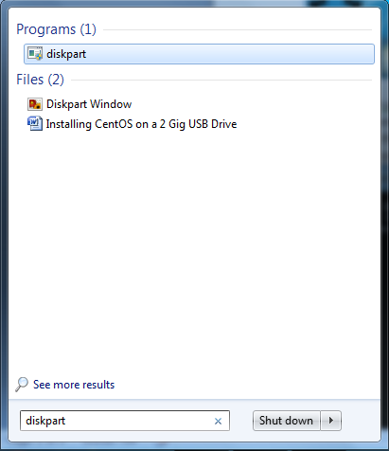

Depress the enter key.

Click “yes” to the “User Access Control” dialog box. This opens the following command window.

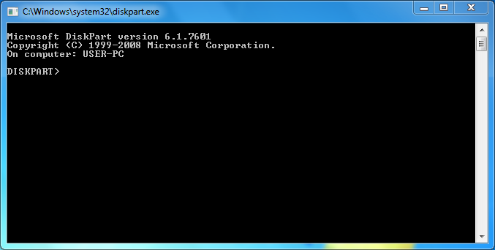

Type” list disk” without the quotes.

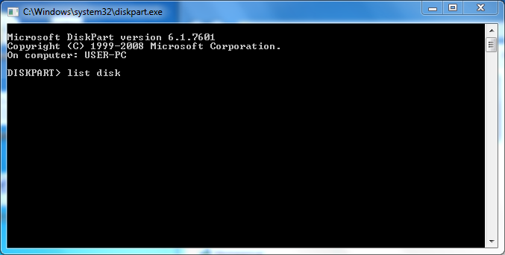

Depress the enter key. This will tell you which disk is your USB drive. Example: disk 1

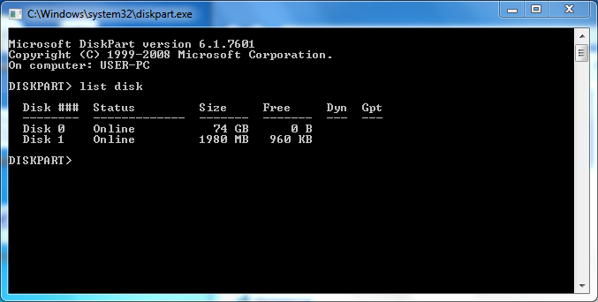

Type “select disk = your USB disk” without the quotes and inserting your drive number for “your USB disk”. Example select disk = 1

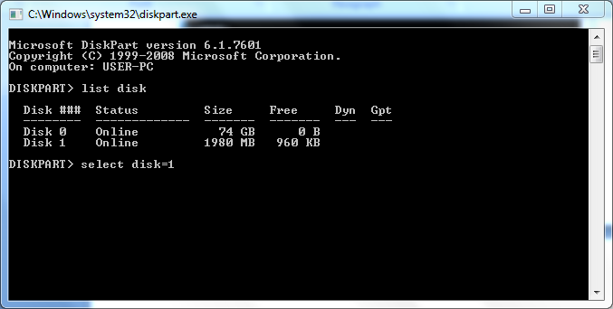

Depress the enter key. You should receive a message “Disk 1 is now the selected disk”.

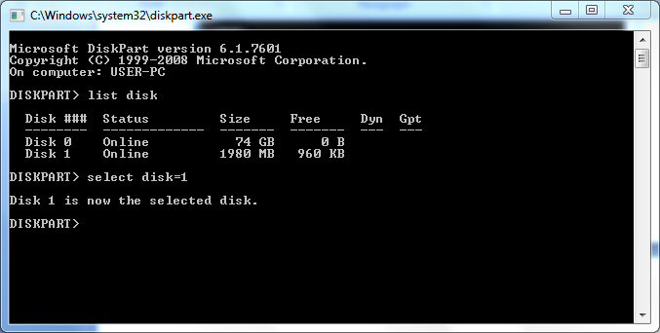

The next step erases your USB device so ensure the correct device is selected. Type “clean”.

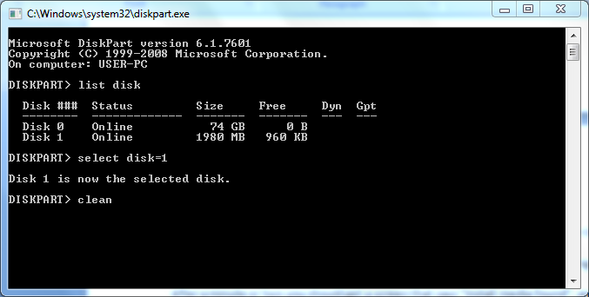

Depress the enter key. You should receive a message “Diskpart succeeded in cleaning the disk”.

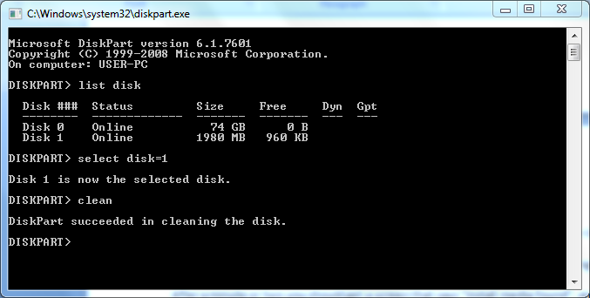

Type “detail disk”

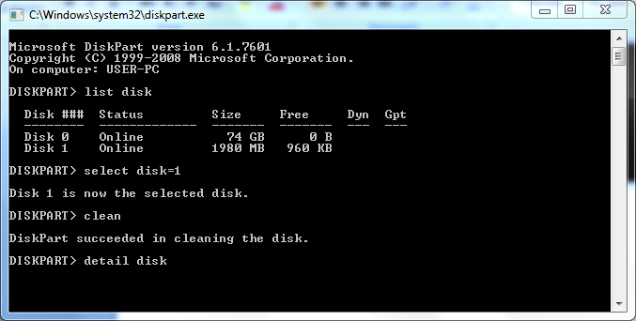

Hit the enter key. Verify status is unusable.

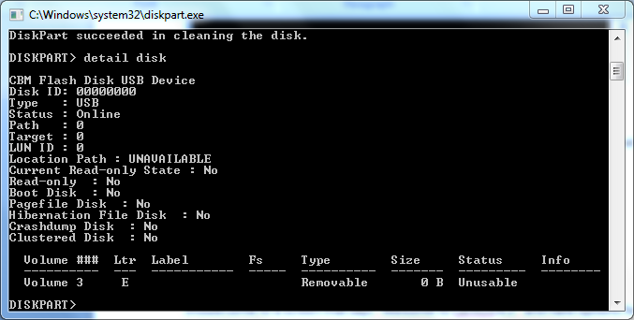

Type “exit”

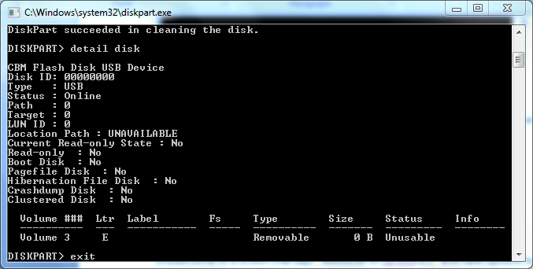

Depress the enter key. The diskpart command window closes, and now the drive is ready to accept CentOS Linux.

**Installing CentOS Minimal 32 bit base load on a USB drive.**

Create a CD of the CentOS minimal 32 bit image.

Put the CD of CentOS minimal 32 bit in the CD Tray of your computer.

Place the USB drive in a USB port on your computer.

Restart your computer and boot to the CD that you just placed in your computer. The CD should start loading and once loaded you should get a screen that says “Welcome to CentOS 6.2!” and have options for installing CentOS 6.2.

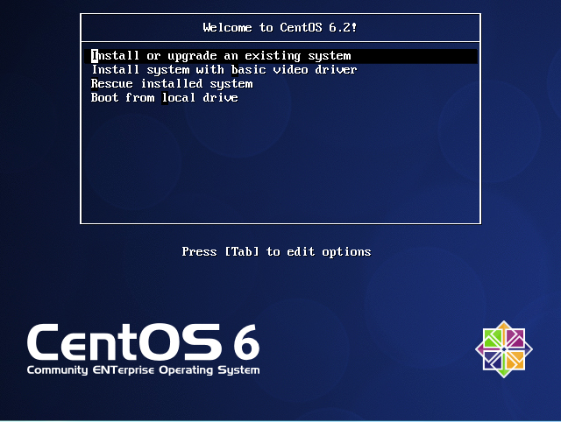

If not selected, select “Install or upgrade an existing system”.

Depress Enter key.

After a few minutes, you should get a screen that says “Welcome to CentOS for i386” and have a box that says “Disc Found” with an OK button, and a Skip button.

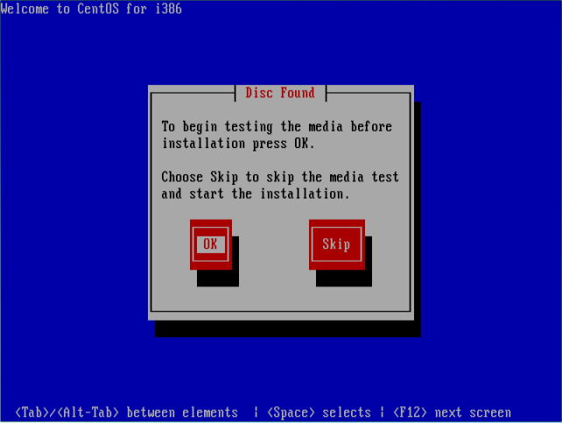

Tab to highlight the Skip button. It will have a gray box around Skip when it is highlighted.

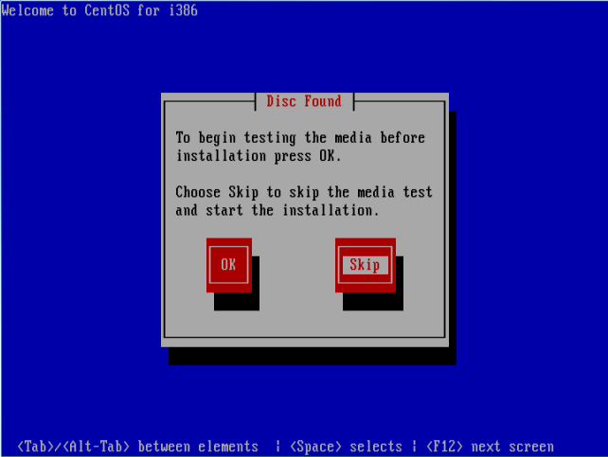

Depress the enter key.

After several seconds you should get a screen that says ”install media found”, and after a few more seconds a screen that has “CentOS 6” in the middle with a “Next” box in the bottom right hand corner.

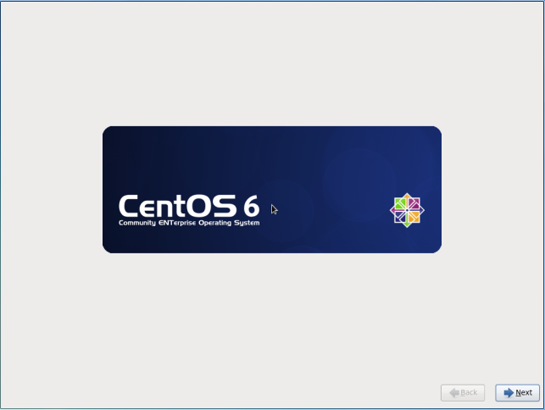

Depress “Next” in the lower right hand corner.

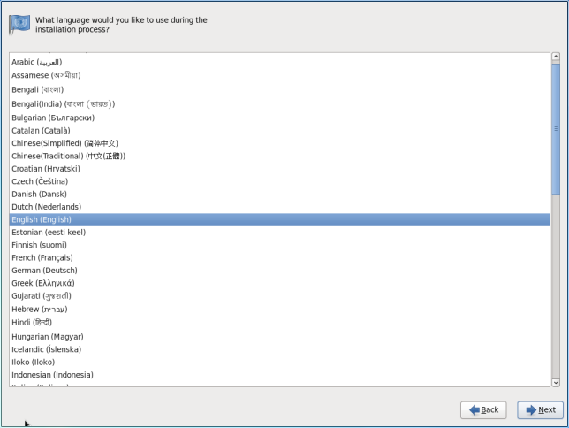

English should be highlighted, if not select English

Depress “Next” in the lower right hand corner.

U.S. English should be selected for appropriate keyboard, if not select U.S. English.

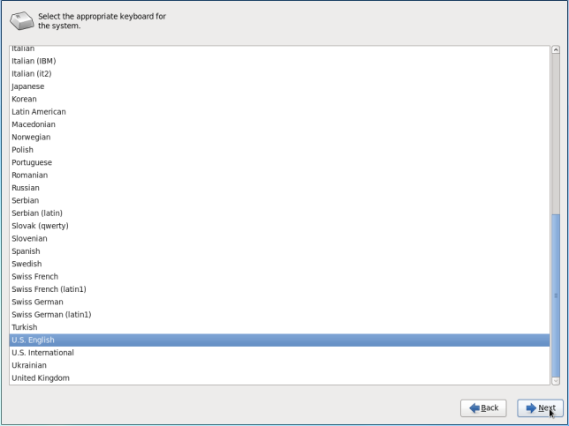

Depress “Next” in the lower right hand corner.

You should be at a screen that says “What type of devices will your installation involve”.

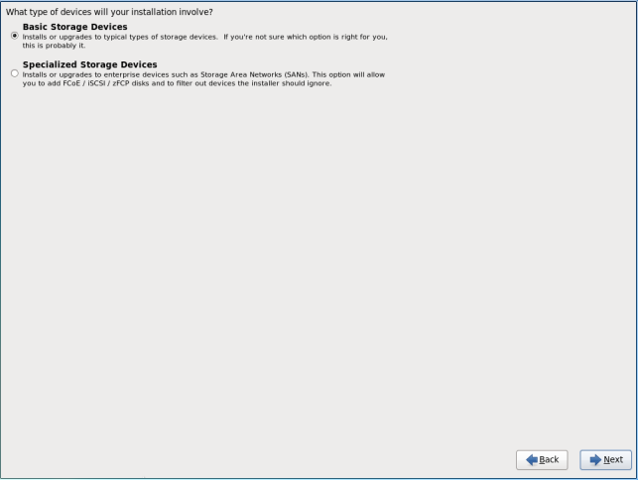

Select “Specialized Storage Devices”.

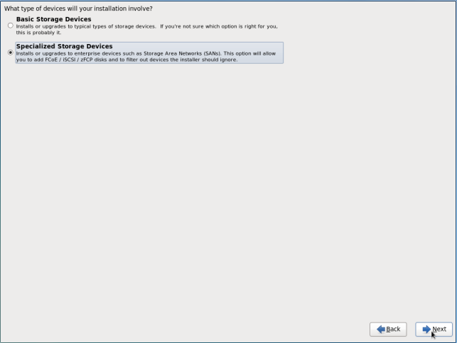

Depress “Next” in the lower right hand corner.

The available drives will be listed on this screen, including your Flash drive. Example: CBM Flash Disk, but yours could say something else.

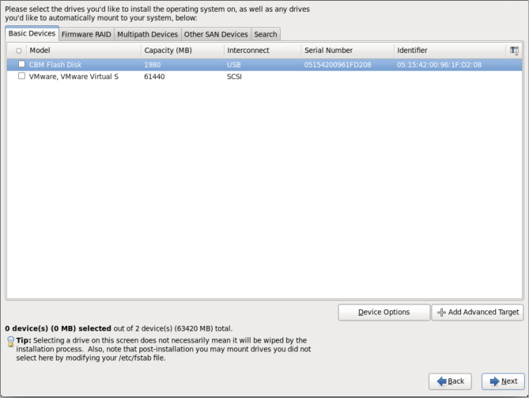

Make sure you select your USB drive by clicking on the box next to your USB Drive.

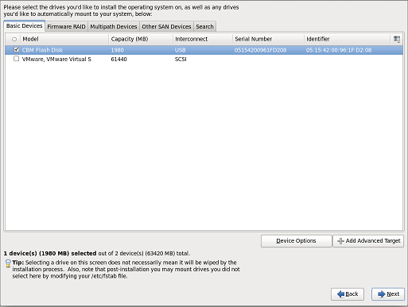

Depress “Next” in the lower right hand corner, after you have selected your USB drive.

The next screen says please name this computer. You can leave this as the default setting or change it to what you would like.

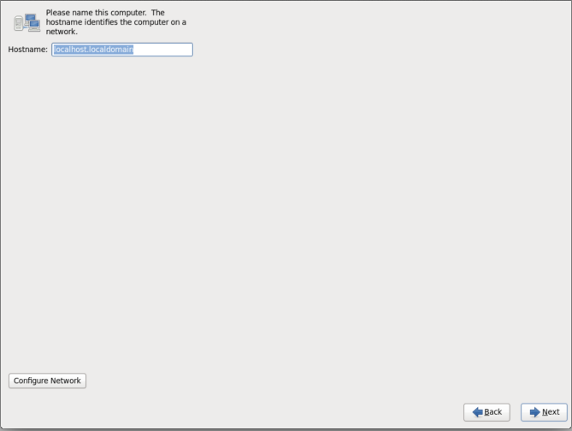

Depress “Next” in the lower right hand corner.

The next screen is for your time zone.

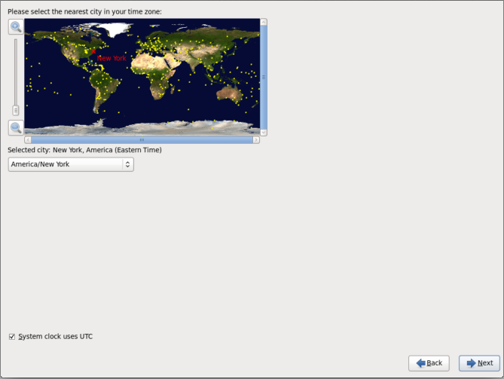

Select nearest city in your time zone. We chose Chicago.

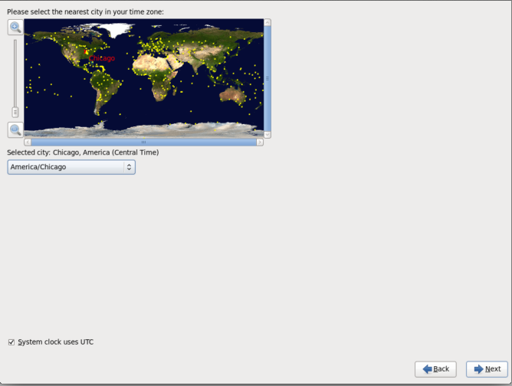

Depress “Next” in the lower right hand corner.

Enter root account password. The password we used was “abc123”.

Confirm: “abc123”.

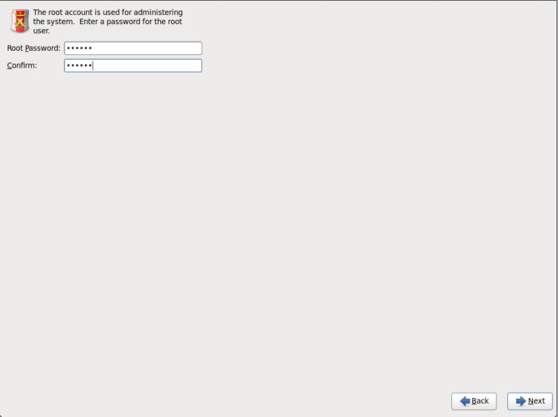

Depress “Next” in the lower right hand corner.

You may received a dialog box that says “You have provided a weak password: it is too simplistic/systematic”.

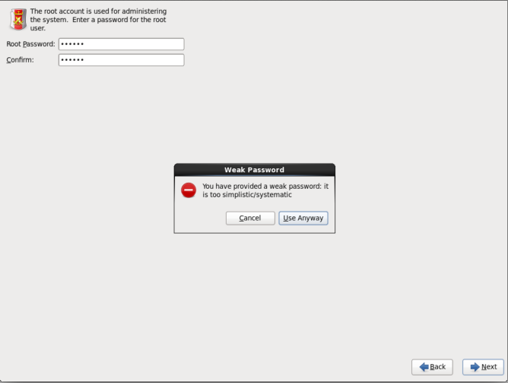

Click “Use Anyway”.

The next screen is “Which type of installation would you like”.

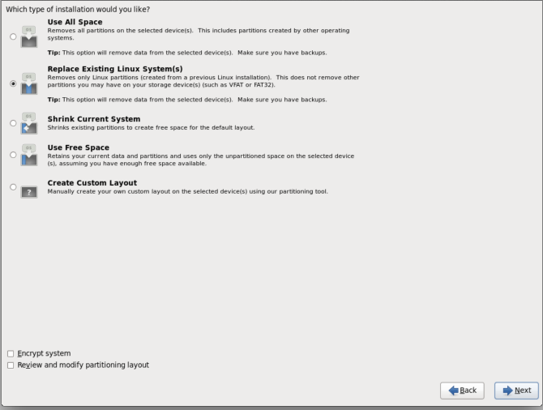

Select “Create Custom Layout”

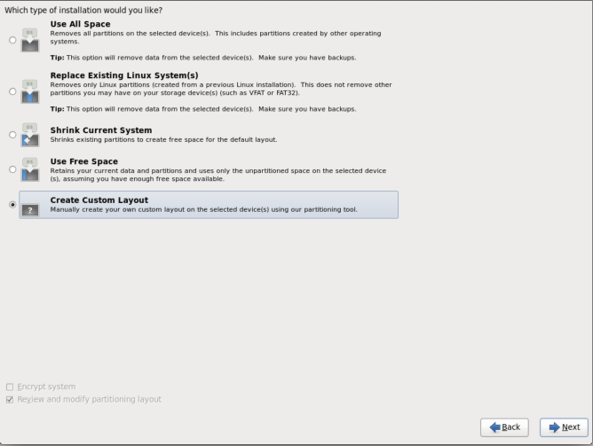

Click Next

This brings you to a screen that says “Please select a device”. It should have only one drive listed, and the size should be the size of your USB drive. Example: sda free 1976.

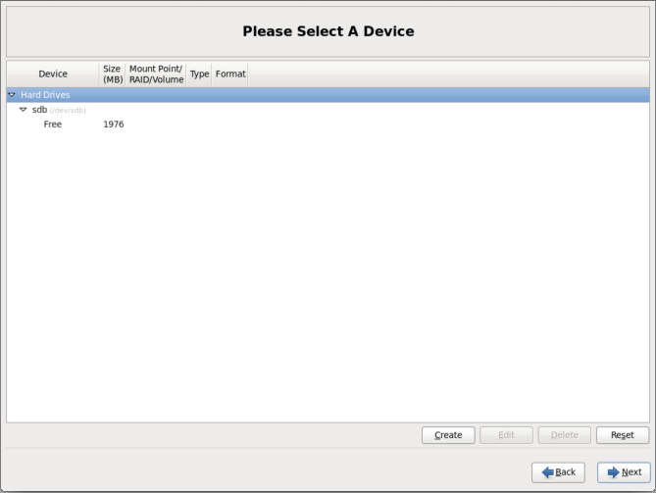

Click the create button

Ensure “standard partition” is highlighted

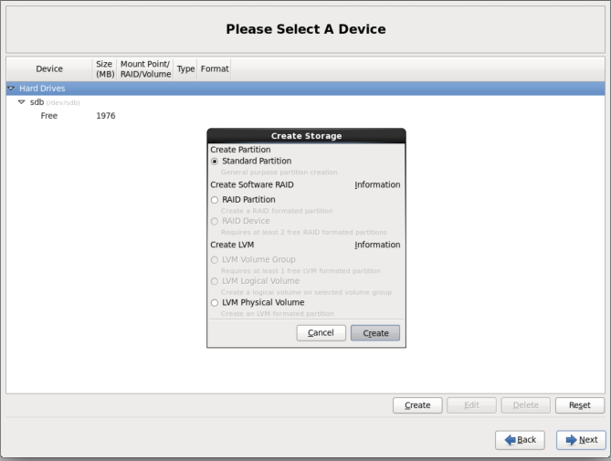

Click the create button in the “Create storage” dialog box.

The “Add a Partition” window opens.

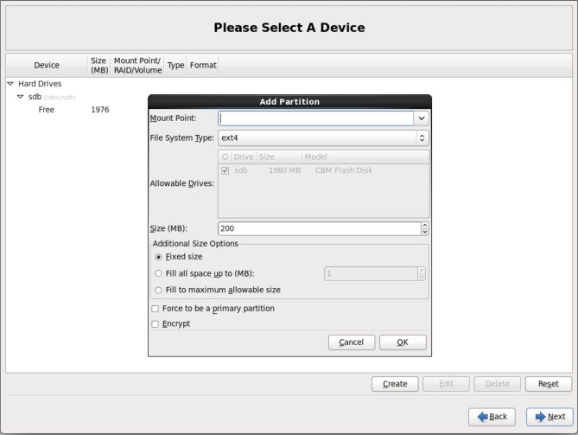

Under mount point click the down arrow and select “/boot”.

Under File System Type click the arrow and select “ext3”

Under size change to “100”. Leave Additional size options “Fixed size”

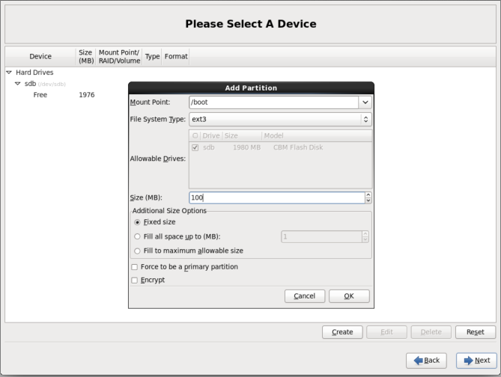

Click “OK”

Your screen should look something like below.

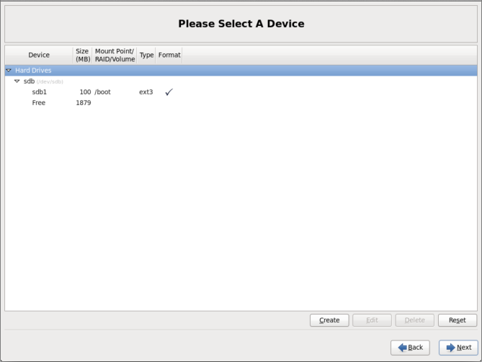

Click the create button again.

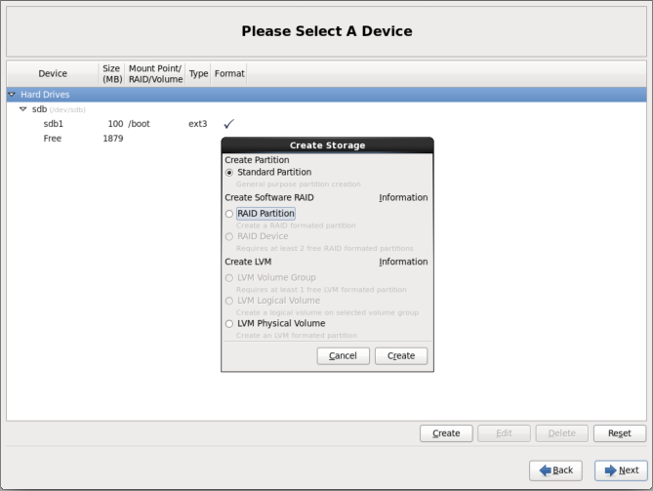

Ensure “standard partition” is highlighted.

Click the create button in the “Create storage” dialog box.

The “Add a Partition” window opens again.

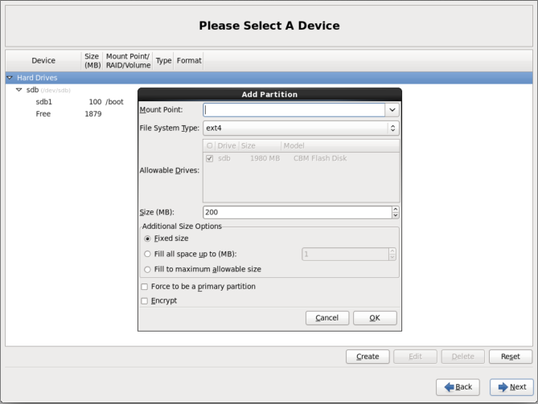

Under mount point click the down arrow and select “/”

Under File System Type click the arrow and select “ext3”

Change Additional Size Options to “Fill to maximum allowable size”

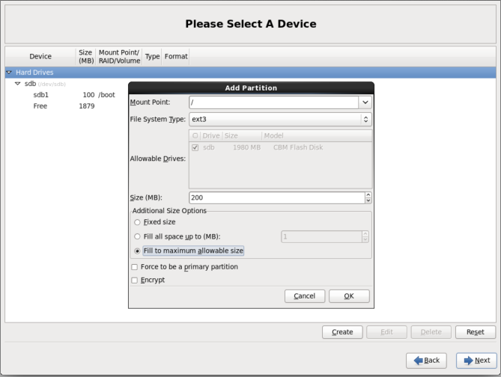

Click “OK”

You should have something similar to below:

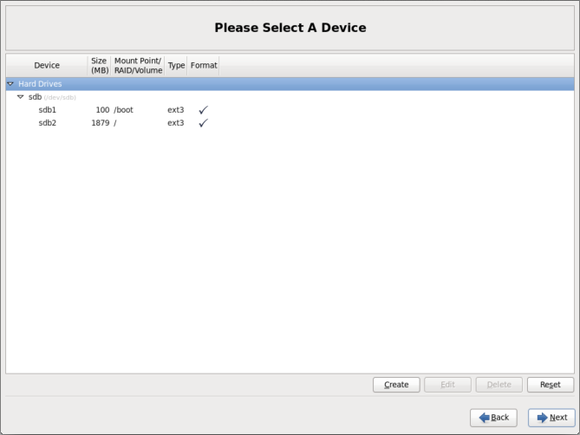

Depress “Next” in the lower right hand corner.

A “partitioning Warnings” dialog box opens stating “You have not specified a swap partition”.

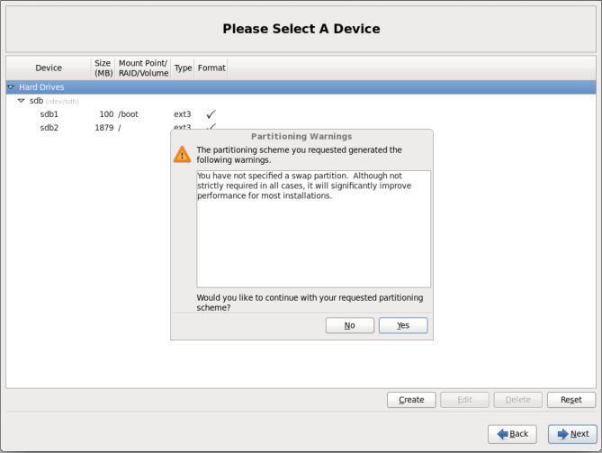

Click yes to “Would you like to continue with your requested partitioning scheme”.

A “Writing storage configuration to disk” dialog box opens up.

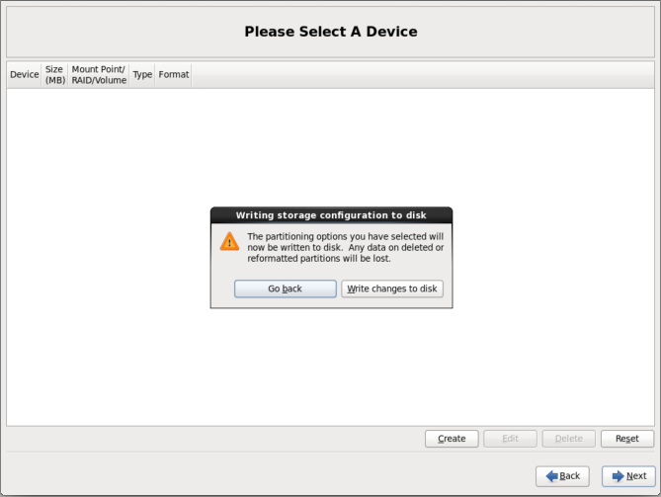

Click “Write changes to disk”.

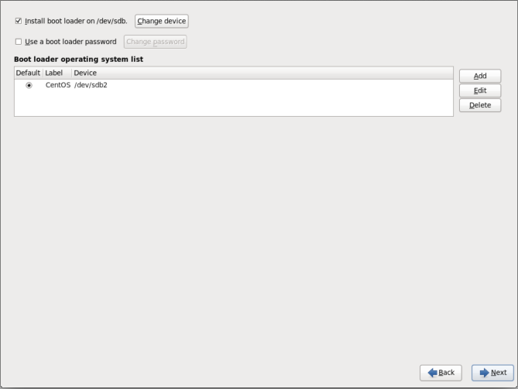

Leave install boot loader on /dev/sda checked, and depress “Next” in the lower right hand corner.

CentOS should start loading.

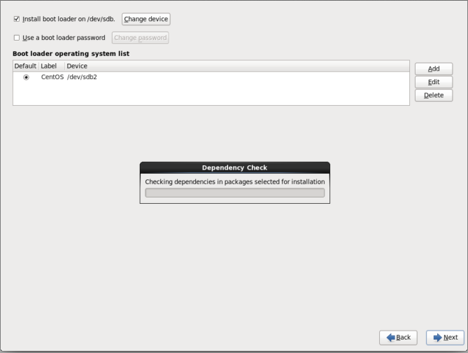

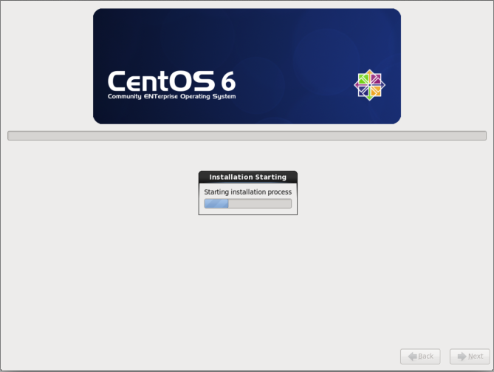

when finished your CD drive will open and a button to reboot your machine should appear.

Click reboot.

At this point you can install the USB drive into the small form factor computer for the rest of the configurations.

Once CentOS Boots, you should be at a screen as below

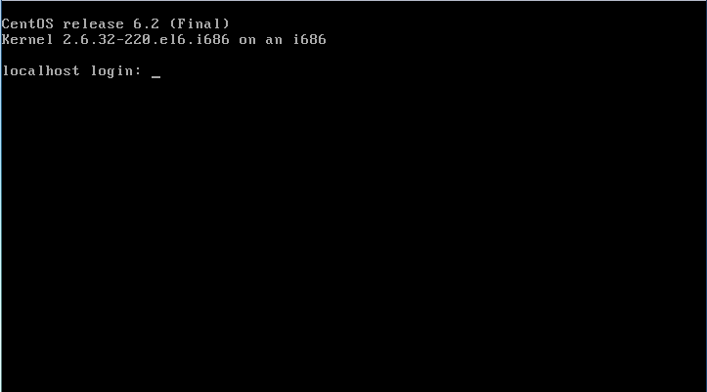

Login as root by entering “root” for localhost login.

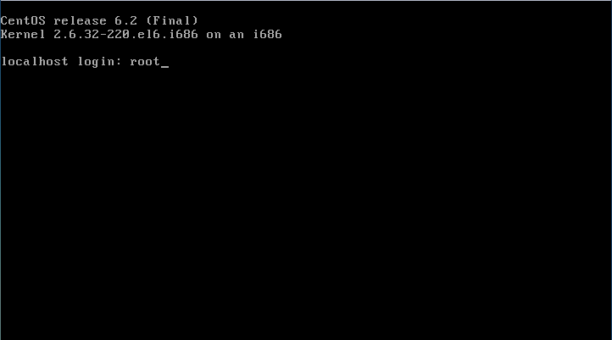

Depress the ”enter” key.

Enter password you set up during install. The screen will not echo the input. Ours was “abc123”.

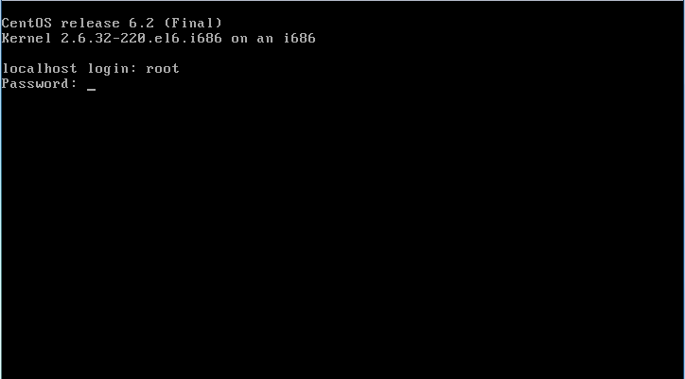

Depress the ”enter” key.

Your screen should look similar to below with a prompt such as “ [root@localhost ~]#”.

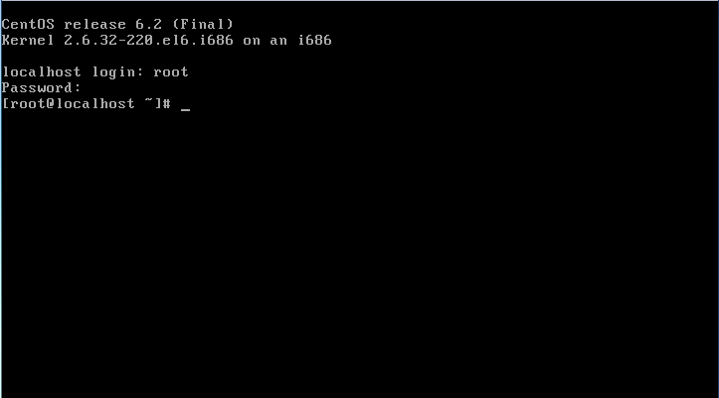

**Configuring CentOS**

**Install the network.** Ensure that you have an Ethernet cable plugged into your machine.

At the “ [root@localhost ~]#” prompt type:

Ifconfig –a.

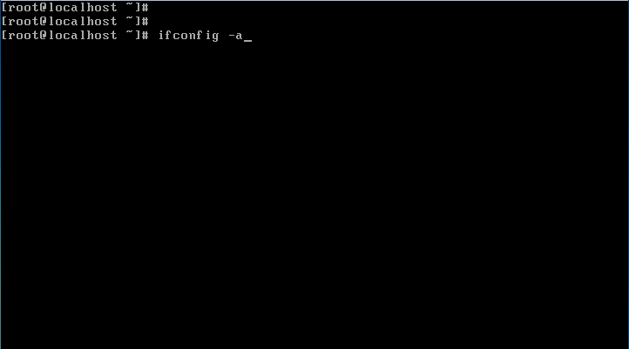

Depress the “enter” key.

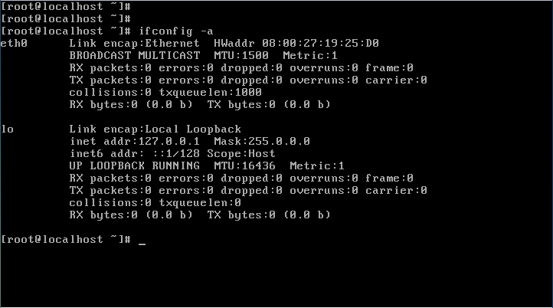

Using this information, edit the ifcfg-“your network adapter” network configuration file by typing:

vi /etc/sysconfig/network-scripts/ifcfg-eth0 as an example for this machine. Your network adapter may be different.

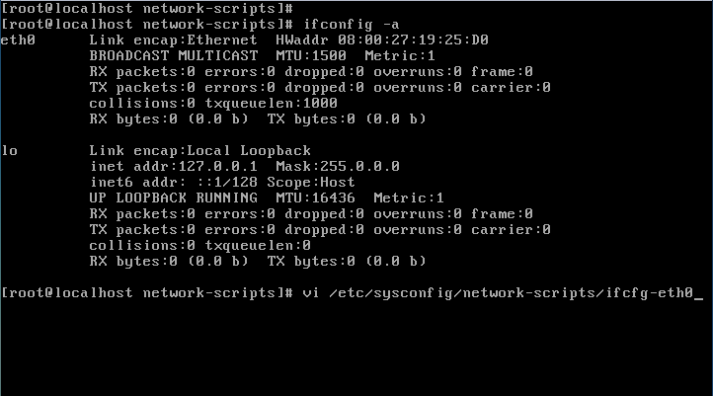

Depress the ”enter” key. If typed correctly your screen should look similar to below.

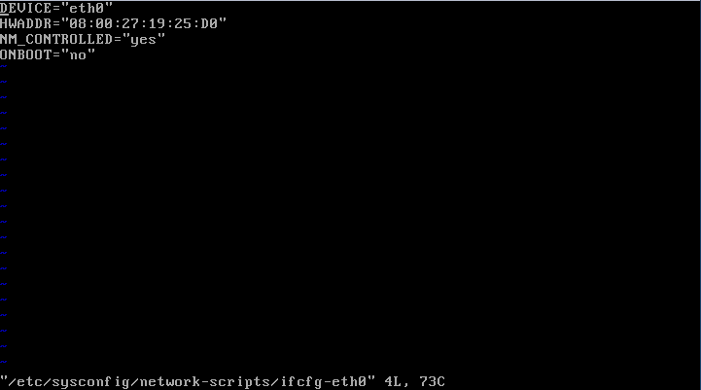

Verify DEVICE and HWADDR correct, and change and or add the following to the ifcfg-eth0 file.

To insert into the file depress the “i” key and up or down arrow as needed.

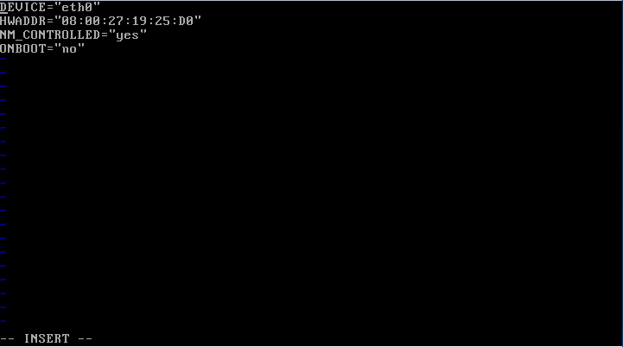

Change: NM_CONTROLLED=“no” and ONBOOT=“yes”.

Add: BOOTPROTO=”dhcp” and verify HWADDR and DEVICE is correct with information from above .

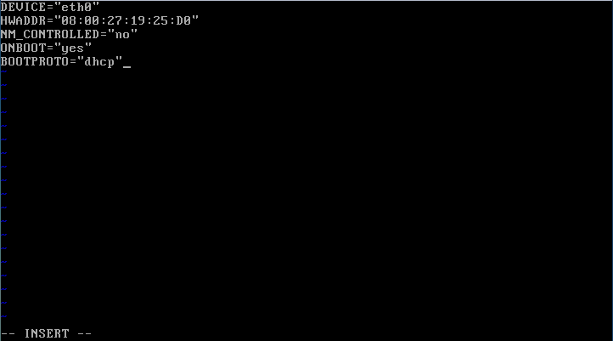

When complete, depress the “esc” key.

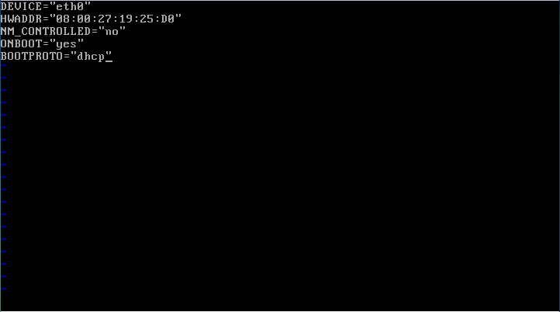

Depress the shift and : keys, depress the w and q keys.

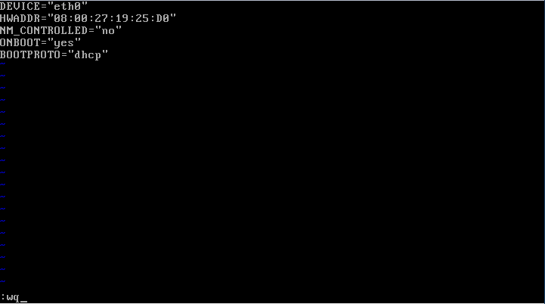

Depress the “enter” key.

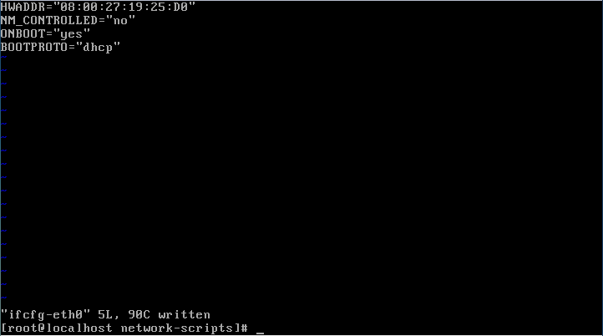

Type “service network restart”.

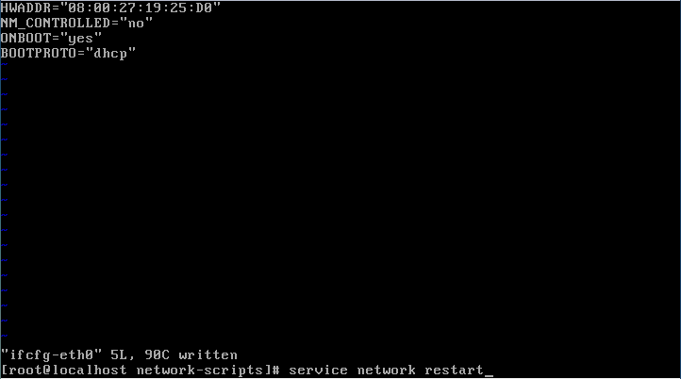

Depress the ”enter” key.

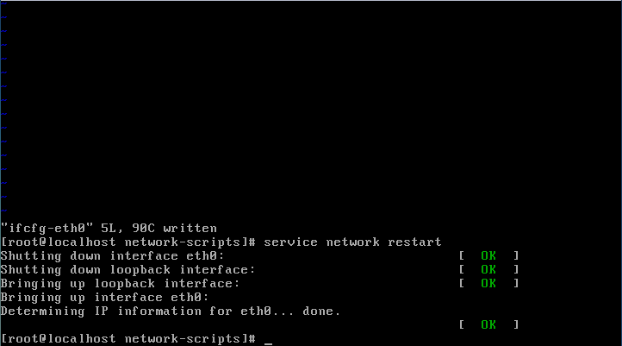

Verify that “Determining IP information for eth0… done. is [ ok ].

**Installing XWindows.**

Type: “yum install xorg-x11-server-Xorg xorg-x11-xinit twm xterm”

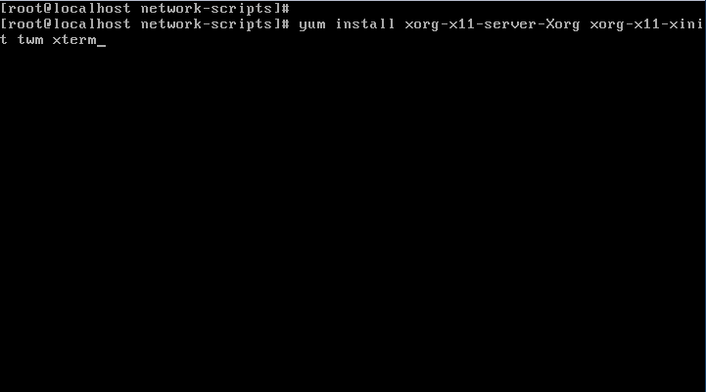

Depress the ”enter” key. You should receive a window as below.

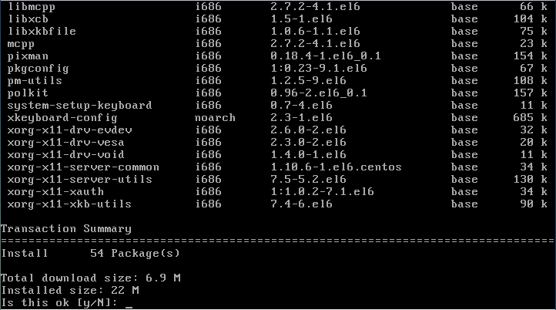

Enter “y” to the question “Is this ok [y/N]:

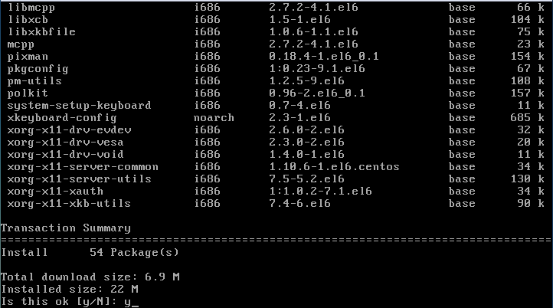

Depress the ”enter” key. After a few seconds you will be prompted again.

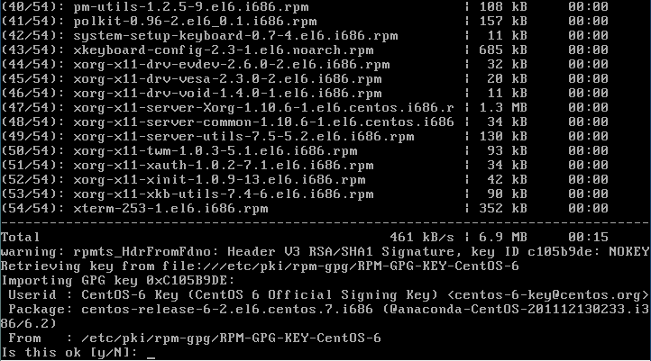

Enter “y” to the question “Is this ok [y/N]:

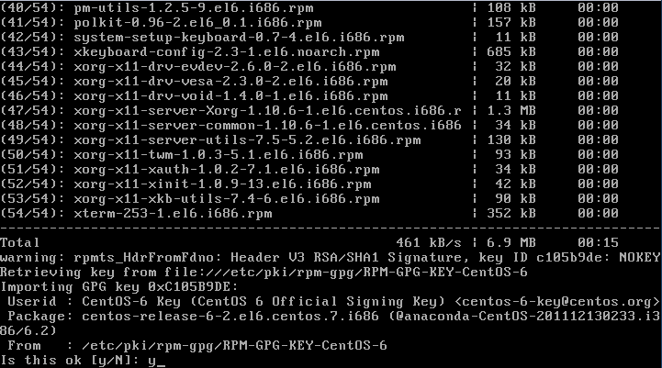

Depress the ”enter” key.

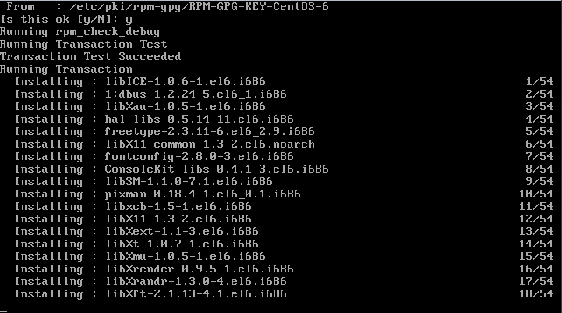

You should see a screen “Running Transaction”, and 1/54 packages starts loading. Wait for all packages to load. Below is the window you should get when all packages have loaded.

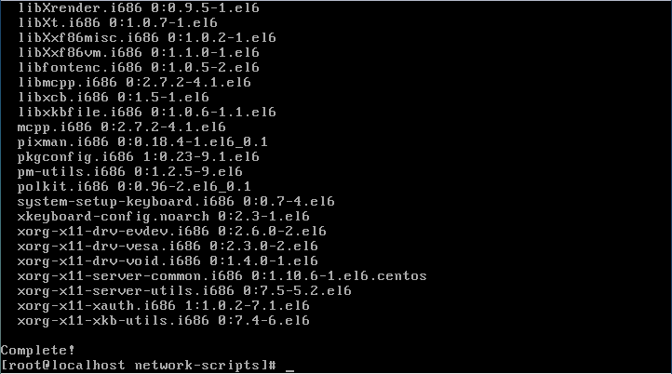

**Install Intel video drivers.**

Type: “yum install xorg-x11-drv-intel “.

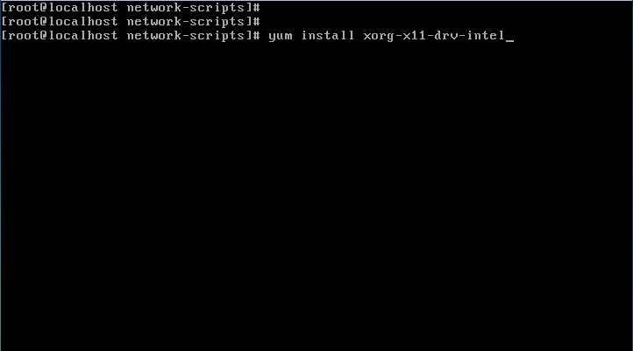

Depress the ”enter” key.

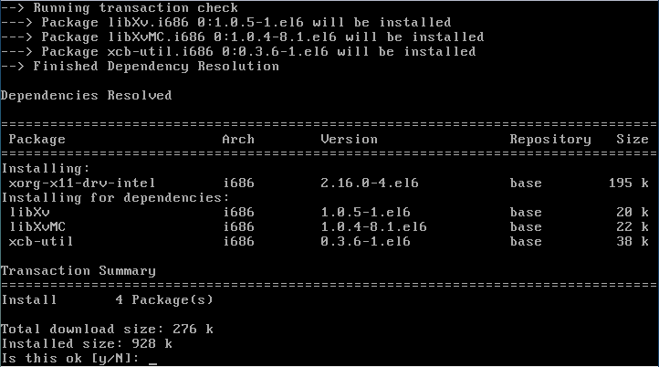

Enter “y” to the question “Is this ok [y/N]:

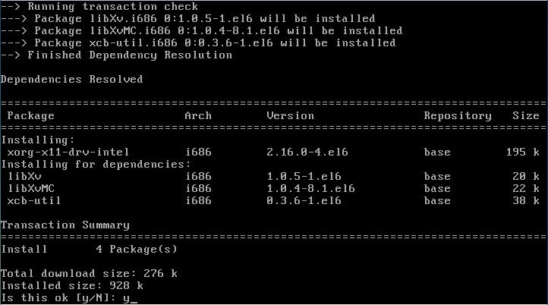

Depress the ”enter” key.

You should see a screen “Running Transaction”, and 1/4 packages starts loading. Wait for all packages to load.

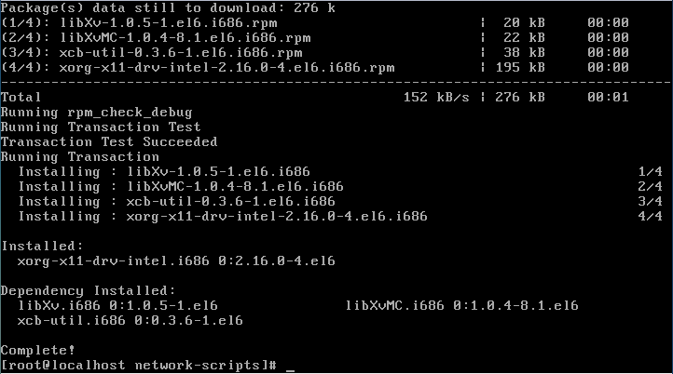

**Install fonts.**

Type: “yum install xorg-x11-fonts-Type1”.

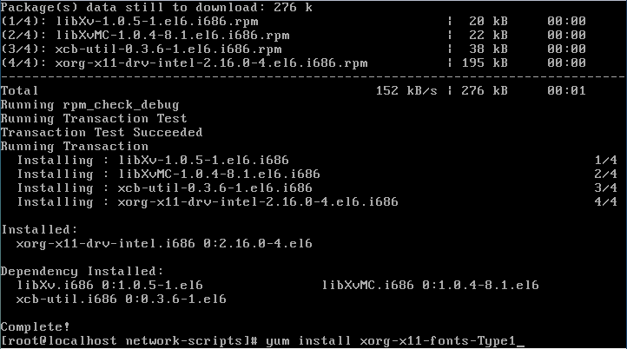

Depress the ”enter” key.

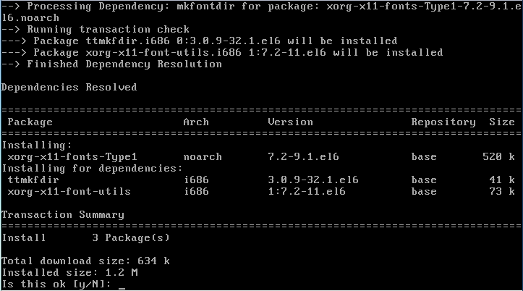

Enter “y” to the question “Is this ok [y/N]:

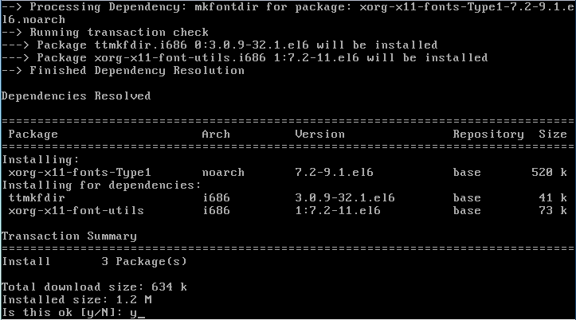

Depress the “enter” key. You should see a screen “Running Transaction”, and 1/3 packages starts loading. Wait for all packages to load.

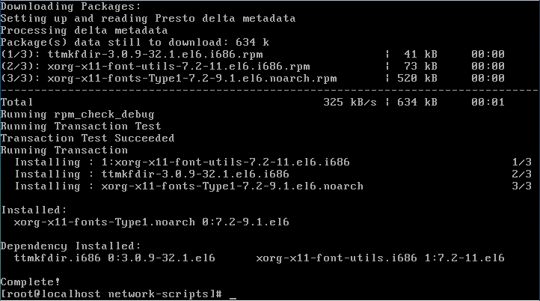

**Install firefox.**

Type: “yum install firefox”.

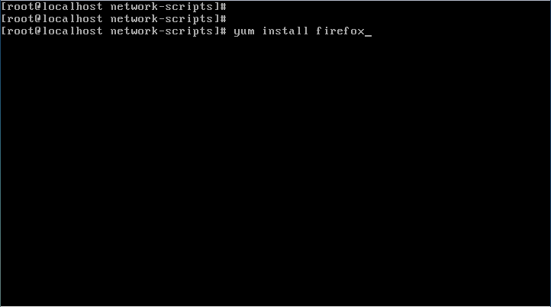

Depress the ”enter” key.

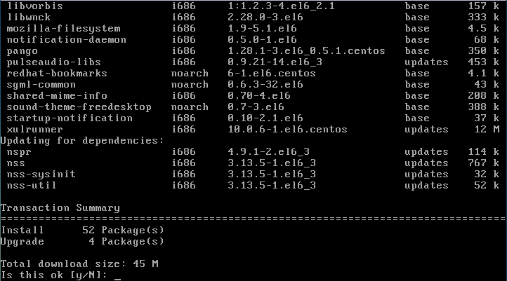

Enter “y” to the question “Is this ok [y/N]:

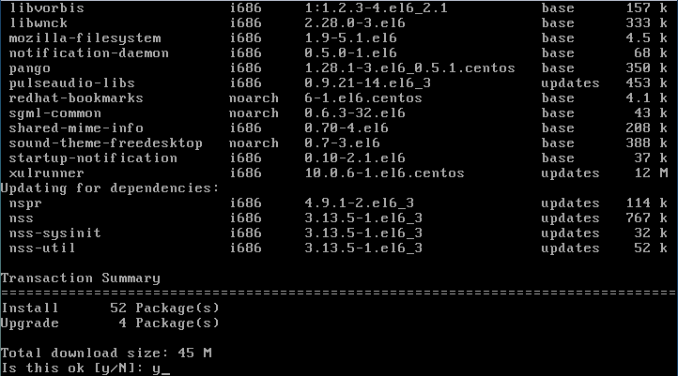

Depress the ”enter” key.

You should see a screen “Running Transaction”, and 1/60 packages starts loading. Wait for all packages to load.

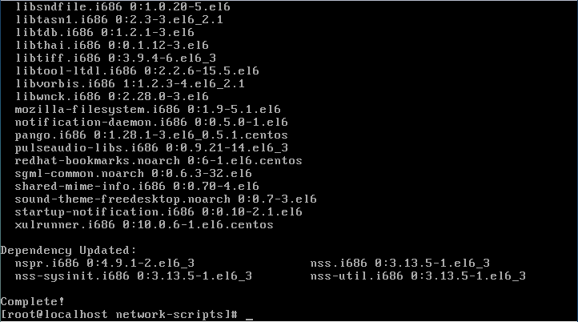

**Add user.**

Type: “useradd user”. user is the user name we are using for the new account.

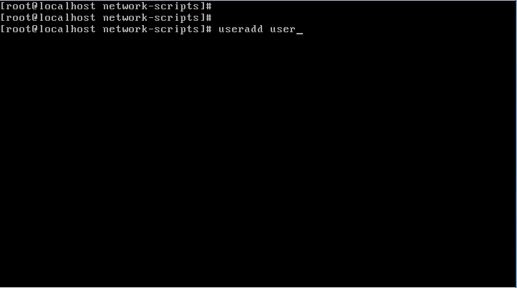

Depress the ”enter” key.

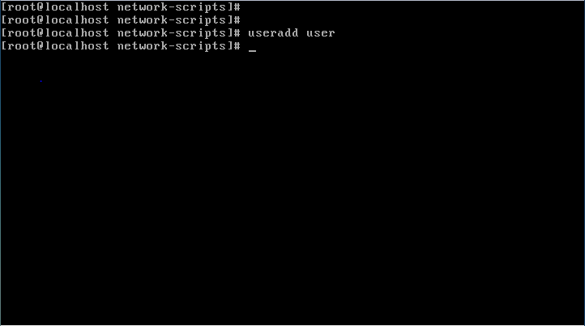

**Create a password for user**.

Type: “passwd user” and depress the “enter” key, where “user” is the user name created above.

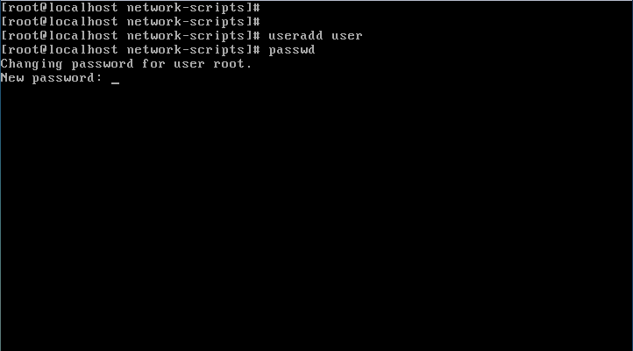

Enter new password and depress enter. Password used was abc123.

We received a message “Bad password: it is too simplistic/systematic

Bad password: is too simple”

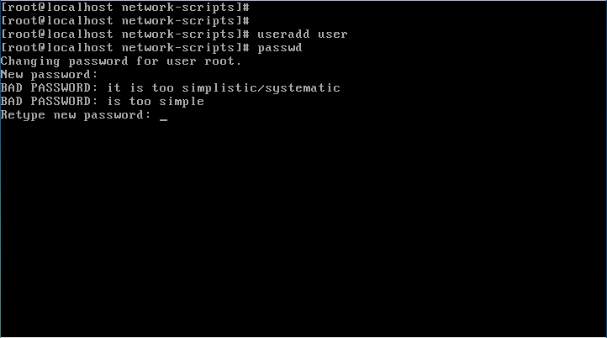

Retype same password and depress the “enter” key.

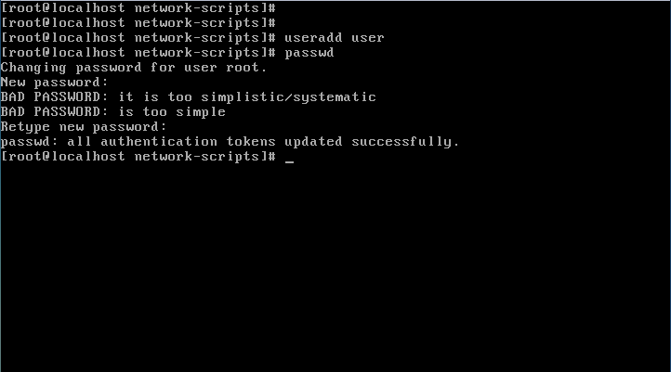

**Configuring xorg.conf file.**

Type: “ Xorg -configure”.

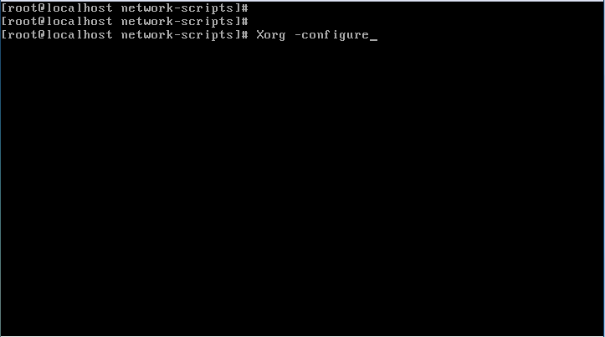

Depress the “enter” key.

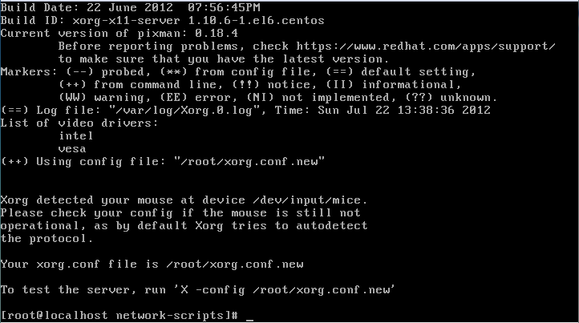

Now we need to edit the xorg.conf.new file for our machine, and copy it to /etc/X11/xorg.conf file.

From the root directory, type: “vi xorg.conf.new”.

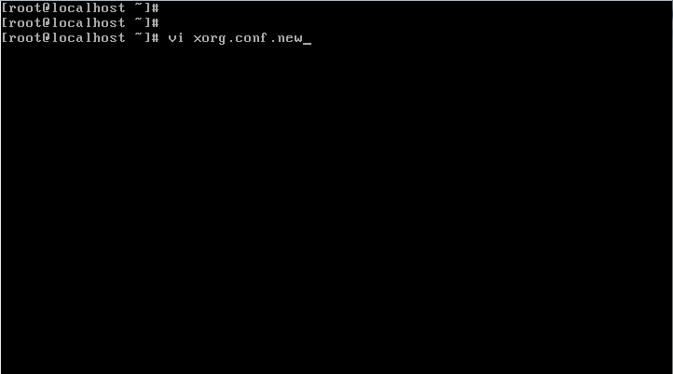

Depress the “enter” key. The file is too large to fit on the entire screen. Use the up and down arrows to find the sections for editing.

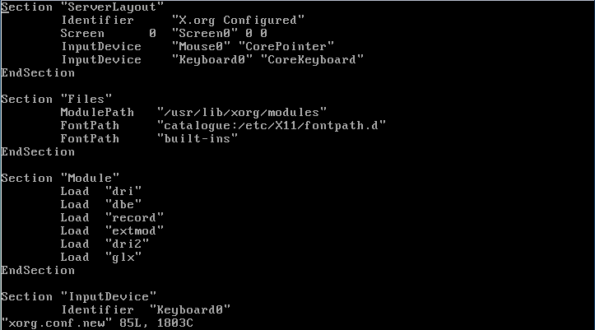

Things to add or remove in the xorg.conf.new file.

Change the Section “ServerLayout” like below.

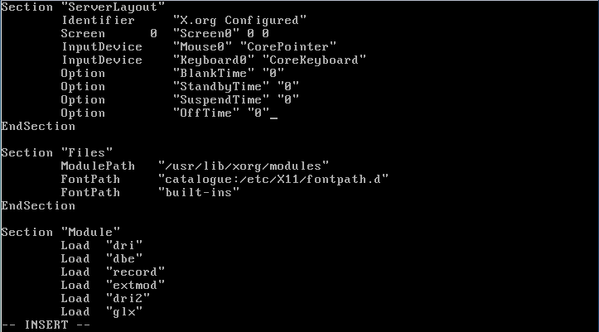

Remove the Section “Monitor” section for “Monitor1”. There should only be one monitor section and it should be “Monitor0”.

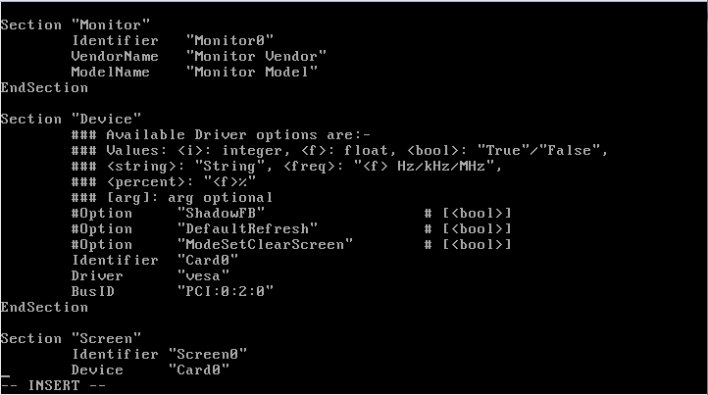

Remove the Section “Device“ section for “Device” Card1. There should only be one “Device” section and it should be “Card0”.

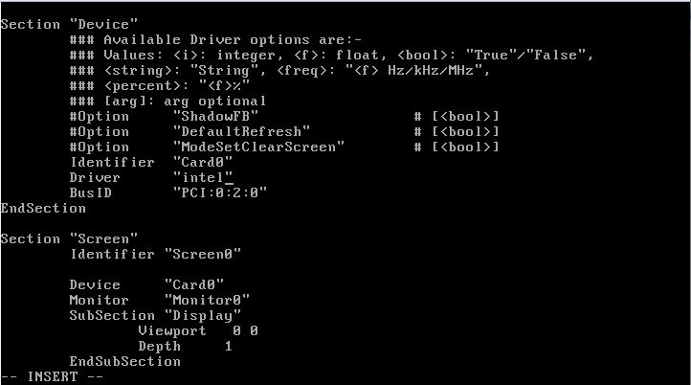

Remove the Section “Screen” section for “Screen1”. There should only be one “Screen” section and it should be “Screen0”.

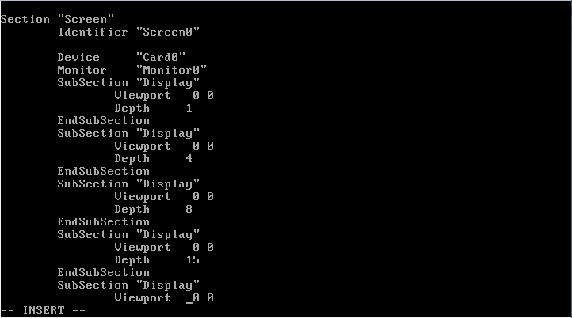

Add a section to the bottom of the xorg.conf file to stop the CTRL ALT Backspace keys from working.

Type: Section “Serverflags”

Option “DontZap” “yes”

EndSection

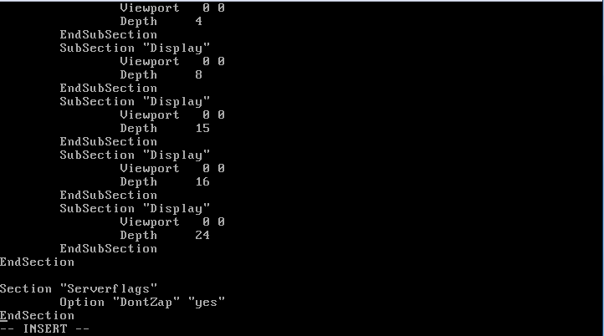

So as a recap, this is what your xorg.conf file should look like after configuration.

Section “ServerLayout”

Identifier “X.org Configured”

Screen 0 “Screen0” 0 0

InputDevice “Mouse0” “CorePointer”

InputDevice “Keyboard0” “CoreKeyboard”

Option “BlankTime” “0”

Option “StandbyTime” “0”

Option “SuspendTime” “0”

Option “OffTime” “0”

EndSection

Section “Files”

ModulePath “/usr/lib/xorg/modules”

FontPath “catalogue:/etc/X11/frontpath.d”

FontPath “built-ins”

EndSection

Section “Module”

Load “dri”

Load “dbe”

Load “glx”

Load “record”

Load “dri2”

Load “extmod”

EndSection

Section “InputDevice”

Identifier “Keyboard0”

Driver “kbd”

EndSection

Section “InputDevice”

Identifier “Mouse0”

Driver “mouse”

Option “Protocol” “auto”

Option “Device” “/dev/input/mice”

Option “ZAxisMapping” “4 5 6 7”

EndSection

Section “Monitor”

Identifier “Monitor0”

VendorName “Monitor Vendor”

ModelName “Monitor Model”

EndSection

Section ”Device”

### Available Driver options are:-

### Values: <i>: integer, <f>: float, <bool>: “True” / “False”,

### <string>: “String”, <freq>: “<f> Hz/kHz/MHz”,

### <percent>: “<f>%”

### [arg]: arg optional

#option “DRI” # [<bool>]

#option “ColorKey” # <i>

#option “VideoKey” # <i>

#option “FallbackDebug” # [<bool>]

#option “Tiling” # [<bool>]

#option “LinearFramebuffer” # [<bool>]

#option “Shadow” # [<bool>]

#option “SwapbuffersWait” # [<bool>]

#option “TripleBuffer” # [<bool>]

#option “XvMC” # [<bool>]

#option “XvPreferOverlay” # [<bool>]

#option “DebugFlushBatches” # [<bool>]

#option “DebugFlushCaches” # [<bool>]

#option “DebugWait” # [<bool>]

#option “HotPlug” # [<bool>]

#option “RelaxedFencing” # [<bool>]

Identifier “Card0”

Driver “intel”

BusID “PCI:0:2:0”

EndSection

Section “Screen”

Identifier “Screen0”

Devices “Card0”

Monitor “Monitor0”

SubSection “Display”

Viewport 0 0

Depth 1

EndSubSection

SubSection “Display”

Viewport 0 0

Depth 4

EndSubSection

SubSection “Display”

Viewport 0 0

Depth 8

EndSubSection

SubSection “Display”

Viewport 0 0

Depth 15

EndSubSection

SubSection “Display”

Viewport 0 0

Depth 16

EndSubSection

SubSection “Display”

Viewport 0 0

Depth 24

EndSubSection

EndSection

Section “Serverflags”

Option “DontZap” “yes”

EndSection

Now copy xorg.conf.new to /etc/X11/xorg.conf.

Type: “cp xorg.conf.new /etc/X11/xorg.conf”.

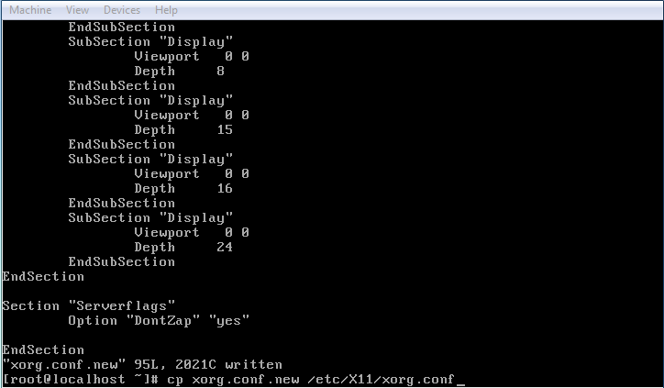

Depress the “enter” key.

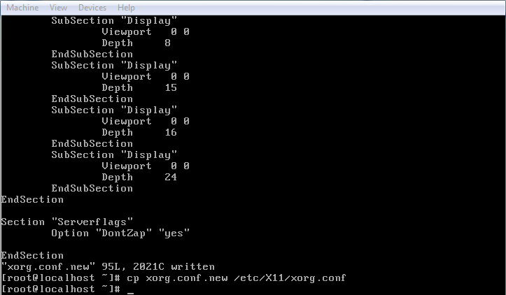

Edit the startx file as below.

Type: “vi /usr/bin/startx”.

Comment out all entries under xinit $client $clientargs -- $server $display $serverargs

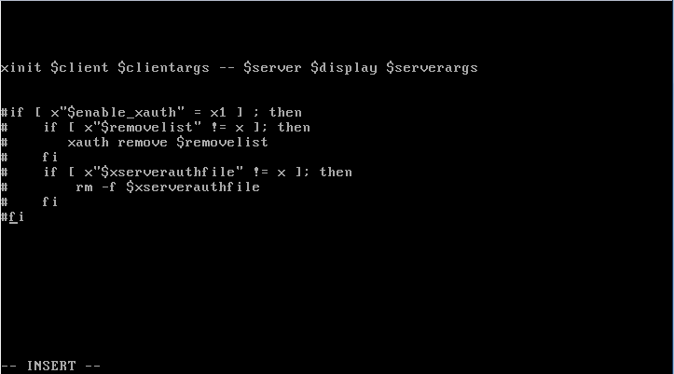

Edit the .bash_profile file as below.

Type: “vi /home/user/.bash_profile”. Add lines under export PATH, pkill xinit and startx

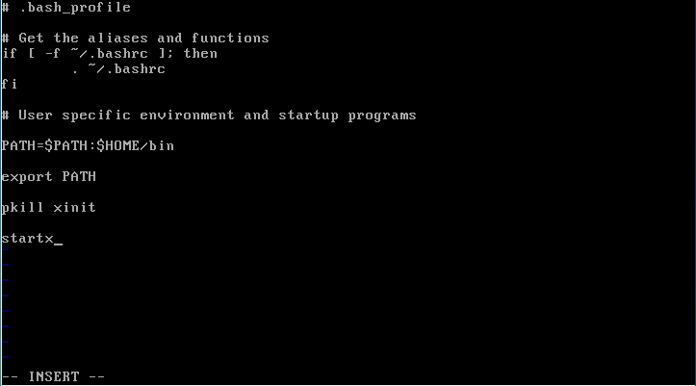

Edit the xinitrc file as below. The file is too large for the screen, so two screen shots will be shown.

Type: “vi /etc/X11/xinit/xinitrc”

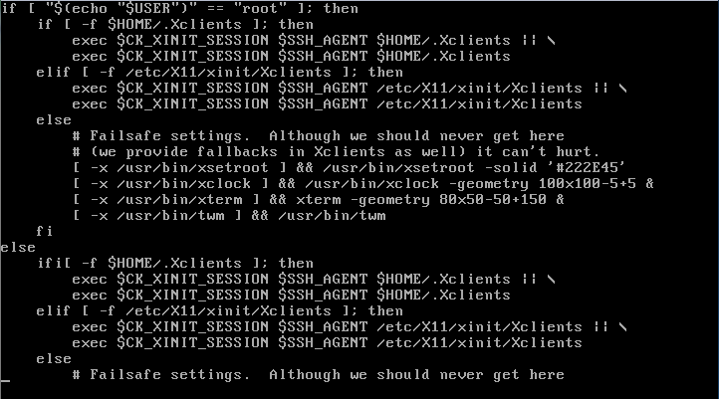

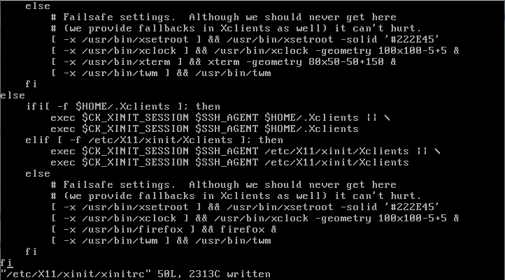

Be sure to add the line:

[ -x /usr/bin/firefox ] && firefox &

To the xinitrc file. See above.

If you are familiar with the yank command in “vi”, it makes this step much easier. Do not hit the “i” key to insert, instead, place the cursor next to the first line you want to copy and then count the number of lines you would like to copy. Type “#lines to copy with a capital Y”. An example would be “14Y”, without the quotes. This will copy or yank, the 14 lines starting with the first line where the cursor is located at. Next move the cursor to the line above where you would like to past the 14 lines, and depress the “p” key. This places the 14 lines below the selected line. To copy a single line, place the cursor on the line you would like to copy and type “yy” two lower case y’s. To paste use the “p” key as above.

What the /etc/X11/xinit/xinitrc file should look like. Comments at beginning of file are left off.

if [ “$(echo “$USER”)” == “root” ]; then

if [ -f $HOME/ .Xclients ]; then

exec $CK_XINIT_SESSION $SSH_AGENT $HOME/ .Xclients || \

exec $CK_XINIT_SESSION $SSH_AGENT $HOME/ .Xclients

elif [ -f /etc/X11/xinit/Xclients ]; then

exec $CK_XINIT_SESSION $SSH_AGENT /etc/X11/xinit/Xclients || \

exec $CK_XINIT_SESSION $SSH_AGENT /etc/X11/xinit/Xclients

else

# Failsafe settings. Although we should never get here

# (we provide fallbacks in Xclients as well) it can’t hurt.

[ -x /usr/bin/xsetroot ] && /usr/bin/xsetroot –solid ‘#222E45’

[ -x /usr/bin/xclock ] && /usr/bin/xclock –geometry 100x100-5+5 &

[ -x /usr/bin/xterm] && /usr/bin/xterm –geometry 80x50-50+150 &

[ -x /usr/bin/twm ] && /usr/bin/twm

fi

else

if [ -f $HOME/ .Xclients ]; then

exec $CK_XINIT_SESSION $SSH_AGENT $HOME/ .Xclients || \

exec $CK_XINIT_SESSION $SSH_AGENT $HOME/ .Xclients

elif [ -f /etc/X11/xinit/Xclients ]; then

exec $CK_XINIT_SESSION $SSH_AGENT /etc/X11/xinit/Xclients || \

exec $CK_XINIT_SESSION $SSH_AGENT /etc/X11/xinit/Xclients

else

# Failsafe settings. Although we should never get here

# (we provide fallbacks in Xclients as well) it can’t hurt.

[ -x /usr/bin/xsetroot ] && /usr/bin/xsetroot –solid ‘#222E45’

[ -x /usr/bin/xclock ] && /usr/bin/xclock –geometry 100x100-5+5 &

[ -x /usr/bin/firefox] && /usr/bin/firefox

[ -x /usr/bin/twm ] && /usr/bin/twm

fi

fi

Delete the Xclients file after backing it up.

Type: “cd /etc/X11/xinit”

“cp Xclients Xclients.bak”

“rm Xclients”

Answer “y” to the question “remove regular file ‘Xclients’?

Depress the “enter” key.

**You are now ready to startx and configure firefox.**

Log out of root and login to user.

Type at the prompt: logout and depress the “enter” key

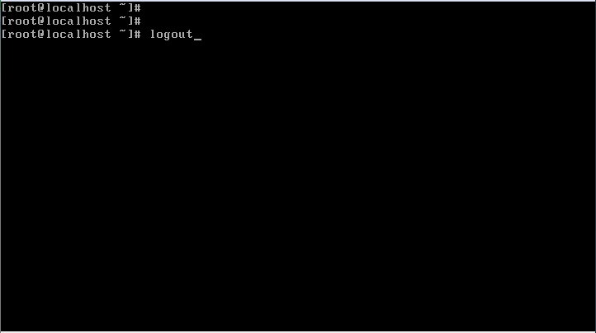

Login as user. Type: “user” and depress the “enter” key. Enter the user password and depress the “enter” key.

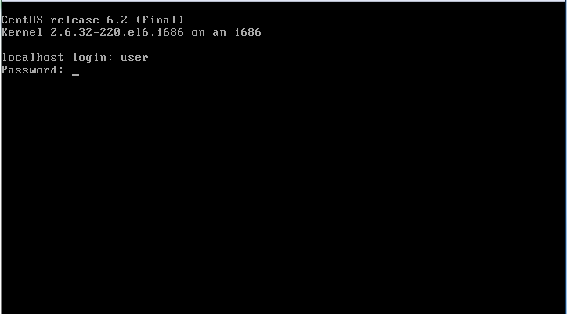

If everything was edited correctly, a window similar to the one below should automatically start. Once the firefox screen comes up set screen width for full screen by pulling box to upper left corner and left click once. Stretch window from right corner as needed.

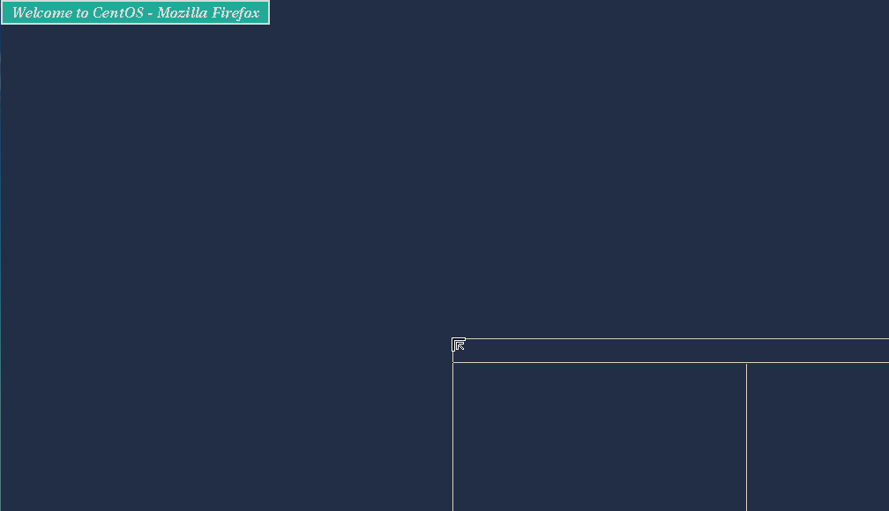

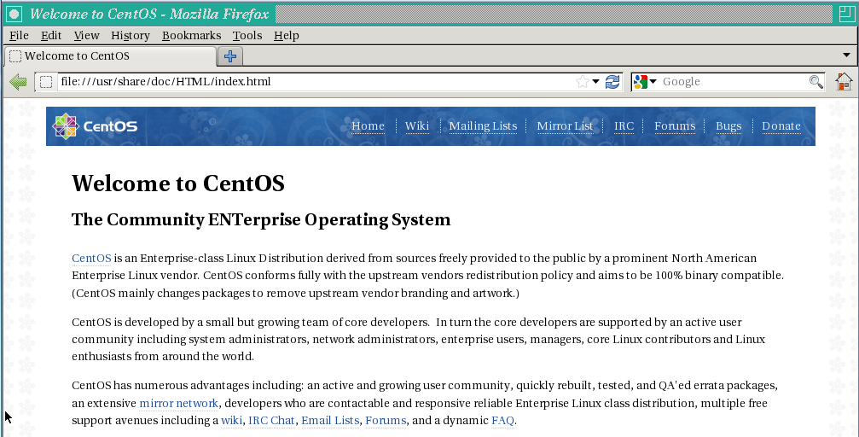

Change the web page homepage to your concerto web site. Click on “Edit” from the tool bar and in the drop down box select “Preferences”. Enter your web address in the “Home Page” box.

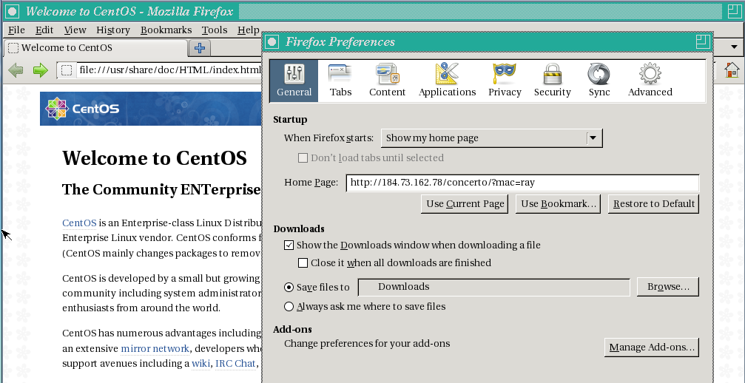

Under privacy tab change “History” to “Never remember history”.

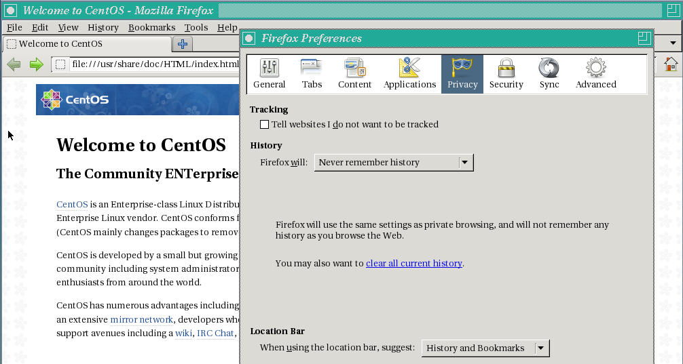

Depress “Close” on the Firefox Preferences box. Select “Tools” from the task bar menu. Select the “add-ons” menu. This brings you to a page such as below.

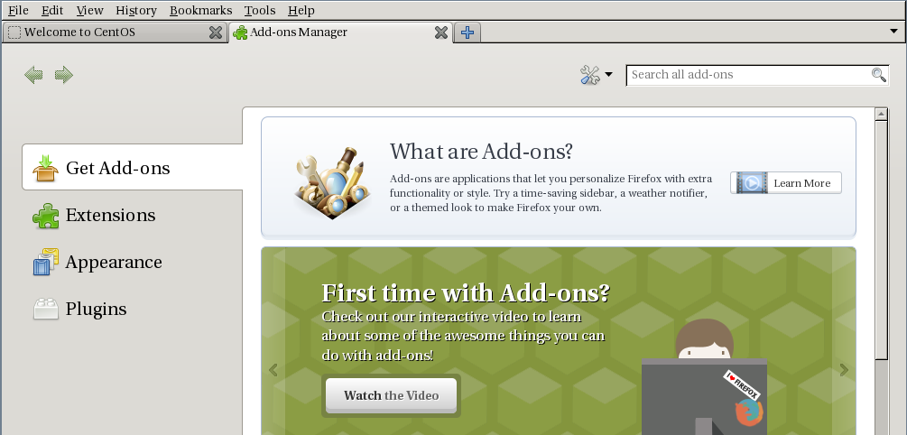

Search all add-ons for “R-Kiosk” and depress the “install” button.

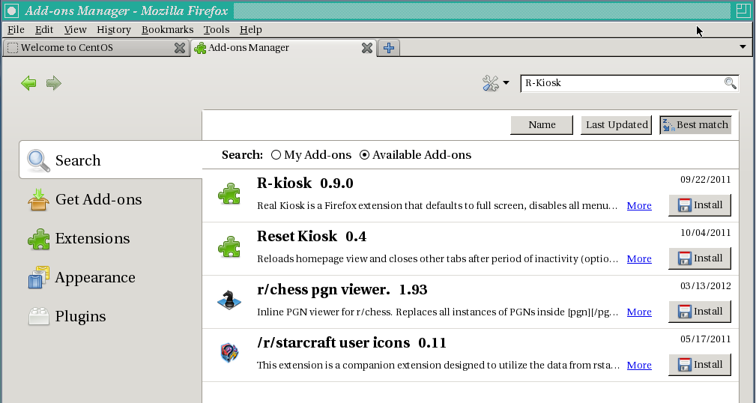

Click “Accept and Install”

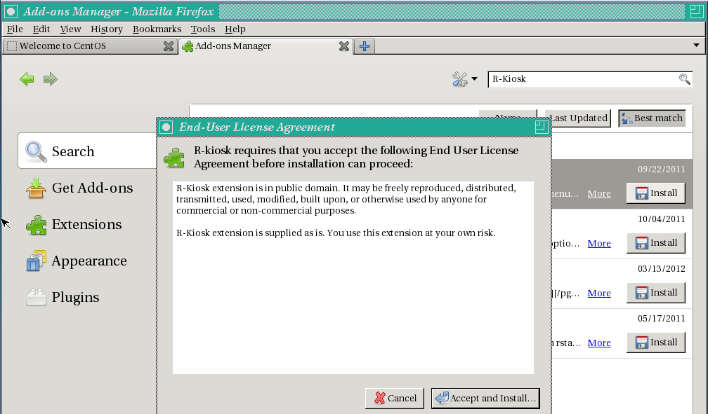

When R-Kiosk is finished loading close out the “add-ons” manager tab. You should only have one tab displayed. Depress the home key in the top right corner to display your web page.



Exit the desktop by selecting “file” and “Quit” from the web page tool bar. Exit to the terminal by holding the left mouse button down and choosing exit. Login as root and edit the xinitrc file as below.

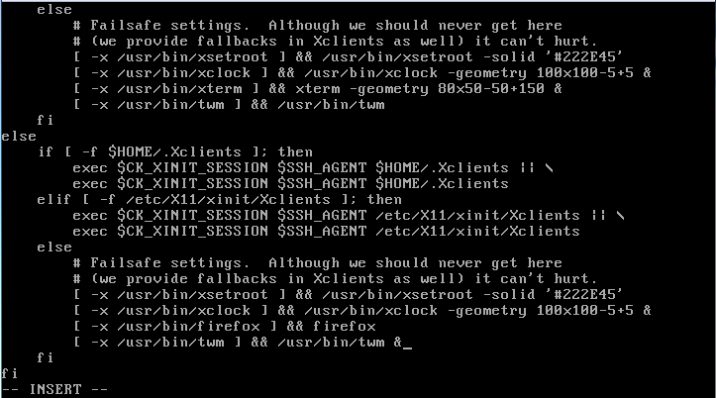

The only thing that needs to change is, remove the “&” sign from the firefox line, and add the “&” sign to the twm line at the bottom of the xinitrc file.

Logout of root and login as user. The web page should automatically start and come up in full screen with no menu bars.

